If You're Thinking Of Having Kids Anytime Ever, This Pie Chart Might Make You Stop…
Curated by Lori White
Could a creeping focus on profits and less on the middle class (and middle-class parents!) in America be a reason no one noticed it got more expensive (for EVERY level of income person, BTW) in America to do the very basic life-thing of raising a child?
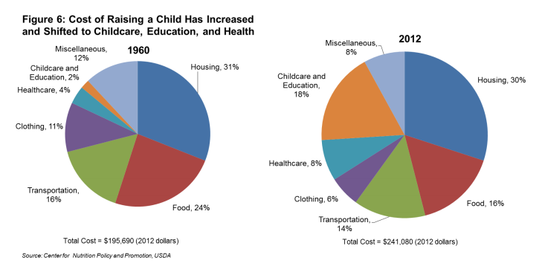
FACT CHECK TIME! The $45,000 increase in the overall cost of raising a child from 1960 to 2012 is based on the U.S. average for children in middle-income, husband-wife families.
You might be looking at the orange pieces of the pie while thinking, "Well, Lori, college got more expensive!" But check this out — this chart covers only K-12 education costs — the increasing cost of college does not even factor in. The report this comes from notes child care costs in 1960 "were negligible," but now that cost takes a sizable piece of the pie because one parent really can't just stay home anymore.
Also, just because sometimes you don’t know really great words that could help you describe your world — get involved with the word PLUTONOMY. A plutonomy is a system where the wealthiest class of society controls economic growth and wealth. I didn’t know it before I read this report either, and now I think about it a lot. Thanks to Investopedia for the definition of plutonomy that I liked the best.

Name ____________________________ Score _______________(worth 7 pts each)

Assignment for “If You're Thinking Of Having Kids Anytime Ever, This Pie Chart Might Make You Stop…”
According to the pie charts and the article:
- What was the percentage of a family income that went to food costs in 1960? ________
- What is the percentage of a family income that went to food costs in 2012?__________
- Has the cost of food for a family gone up or down? ________
- What was the percentage of a family income that went to childcare and education in 1960?________
- What was the percentage of a family income that went to childcare and education in 2012?________
- Have the childcare and education costs per family gone up or down? __________
- Did families spend more or less money on clothing in 1960 than in 2012? ________
- What was the cost of raising a child in 1960? ______________________
- What was the cost of raising a child in 2012? ______________________
- Does the chart cover college costs or just K-12 costs? _______________
- Healthcare costs for families have doubled since 1960 according to the chart. What percentage of their income did families spend on their children’s healthcare in 1960? ______
- Why, according to the article, have childcare costs gone up? _____________________________________________________________________
- What does “plutonomy” mean? ________________________________________________________________________________________________________________________________________________________________________________________________________________________
- The author cites where she got the definition for the word “plutonomy.” What is the name of the website where she learned this? ______________________________________
- How many more dollars does it cost to raise a child in 2012 than it did in 1960? $___,_____
- The data for this chart was based on children in ________income, husband-wife families.

